Chapter 12, Problem 66.

A three-phase, four-wire system operating with a 208-V line voltage is shown in Fig. 12.71. The source voltages are balanced. The power absorbed by the resistive wye-connected load is measured by the three-wattmeter method. Calculate:

(a) the voltage to neutral
(b) the currents I₁, I₂, I₃, and I_{n}
(c) the readings of the wattmeters
(d) the total power absorbed by the load

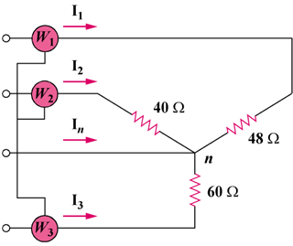

Figure 12.71
For Prob. 12.66.

